**2. Microservices with API gateway**

**Creating Microservices for account and loan**

1. **Account Microservice**

AccountController.java

**package** com.cognizant.account;

**import** org.springframework.web.bind.annotation.GetMapping;

**import** org.springframework.web.bind.annotation.PathVariable;

**import** org.springframework.web.bind.annotation.RestController;

@RestController

**public** **class** AccountController {

@GetMapping("/accounts/{number}")

**public** Account getAccount(@PathVariable String number) {

// Dummy response without backend connectivity

Account account = **new** Account();

account.setNumber("00987987973432");

account.setType("savings");

account.setBalance(234343);

**return** account;

}

}

Account.java

**package** com.cognizant.account;

**public** **class** Account {

**private** String number;

**private** String type;

**private** **long** balance;

// Constructors

**public** Account() {}

**public** Account(String number, String type, **long** balance) {

**this**.number = number;

**this**.type = type;

**this**.balance = balance;

}

// Getters and Setters

**public** String getNumber() {

**return** number;

}

**public** **void** setNumber(String number) {

**this**.number = number;

}

**public** String getType() {

**return** type;

}

**public** **void** setType(String type) {

**this**.type = type;

}

**public** **long** getBalance() {

**return** balance;

}

**public** **void** setBalance(**long** balance) {

**this**.balance = balance;

}

}

AccountApplication.java

**package** com.cognizant.account;

**import** org.springframework.boot.SpringApplication;

**import** org.springframework.boot.autoconfigure.SpringBootApplication;

@SpringBootApplication

**public** **class** AccountApplication {

**public** **static** **void** main(String[] args) {

SpringApplication.*run*(AccountApplication.**class**, args);

}

}

**Output:**

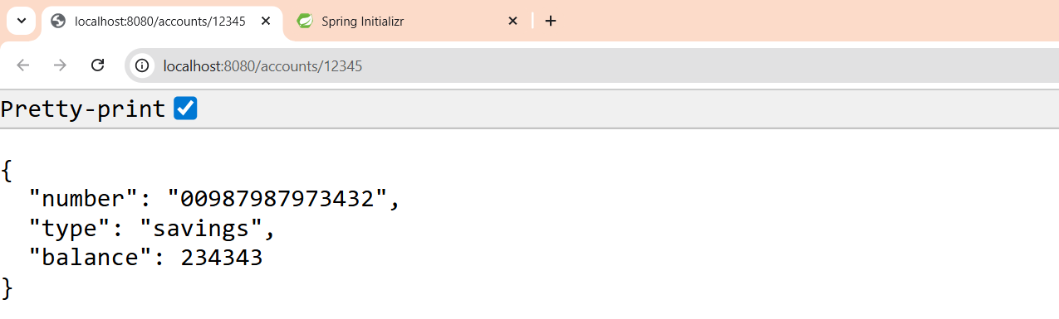

1. **Loan Microservice**

LoanController.java

**package** com.cognizant.loan;

**import** org.springframework.web.bind.annotation.GetMapping;

**import** org.springframework.web.bind.annotation.PathVariable;

**import** org.springframework.web.bind.annotation.RestController;

@RestController

**public** **class** LoanController {

@GetMapping("/loans/{number}")

**public** Loan getLoan(@PathVariable String number) {

// Dummy response without backend connectivity

Loan loan = **new** Loan();

loan.setNumber("H00987987972342");

loan.setType("car");

loan.setLoan(400000);

loan.setEmi(3258);

loan.setTenure(18);

**return** loan;

}

}

Loan.java

**package** com.cognizant.loan;

**public** **class** Loan {

**private** String number;

**private** String type;

**private** **long** loan;

**private** **int** emi;

**private** **int** tenure;

// Constructors

**public** Loan() {}

**public** Loan(String number, String type, **long** loan, **int** emi, **int** tenure) {

**this**.number = number;

**this**.type = type;

**this**.loan = loan;

**this**.emi = emi;

**this**.tenure = tenure;

}

// Getters and Setters

**public** String getNumber() {

**return** number;

}

**public** **void** setNumber(String number) {

**this**.number = number;

}

**public** String getType() {

**return** type;

}

**public** **void** setType(String type) {

**this**.type = type;

}

**public** **long** getLoan() {

**return** loan;

}

**public** **void** setLoan(**long** loan) {

**this**.loan = loan;

}

**public** **int** getEmi() {

**return** emi;

}

**public** **void** setEmi(**int** emi) {

**this**.emi = emi;

}

**public** **int** getTenure() {

**return** tenure;

}

**public** **void** setTenure(**int** tenure) {

**this**.tenure = tenure;

}

}

LoanApplication.java

**package** com.cognizant.loan;

**import** org.springframework.boot.SpringApplication;

**import** org.springframework.boot.autoconfigure.SpringBootApplication;

@SpringBootApplication

**public** **class** LoanApplication {

**public** **static** **void** main(String[] args) {

SpringApplication.*run*(LoanApplication.**class**, args);

}

}

**Output:**

